Experiment 4.3 (12)
Chandan Sharma [23BIS70098]
Title
Concurrent Ticket Booking System with Seat Locking and Confirmation
Procedure:
Create a Node.js and Express.js application that simulates a ticket booking system for events or movie theaters. Implement endpoints to view available seats, temporarily lock a seat for a user, and confirm the booking. Design a seat locking mechanism so that when a seat is locked, it cannot be locked or booked by other users until it is either confirmed or the lock expires automatically (for example, after 1 minute).
Store seat states in an in-memory data structure for simplicity. Include clear success and error messages for different scenarios, such as trying to lock an already locked or booked seat, or confirming a seat without a lock. Test your API by simulating concurrent requests to demonstrate that the locking logic correctly prevents double booking and ensures reliable seat allocation.
Expected Output
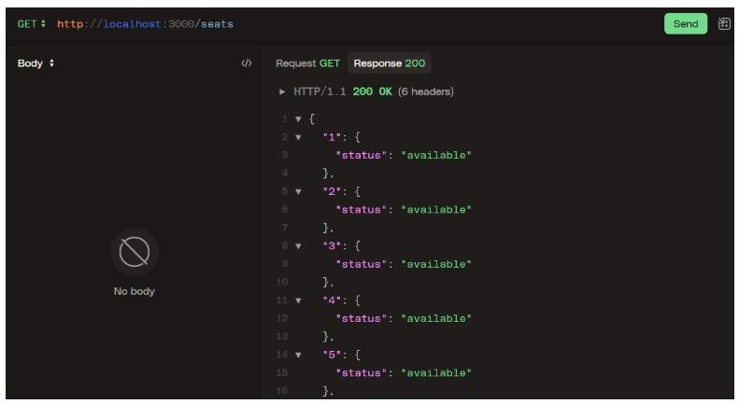
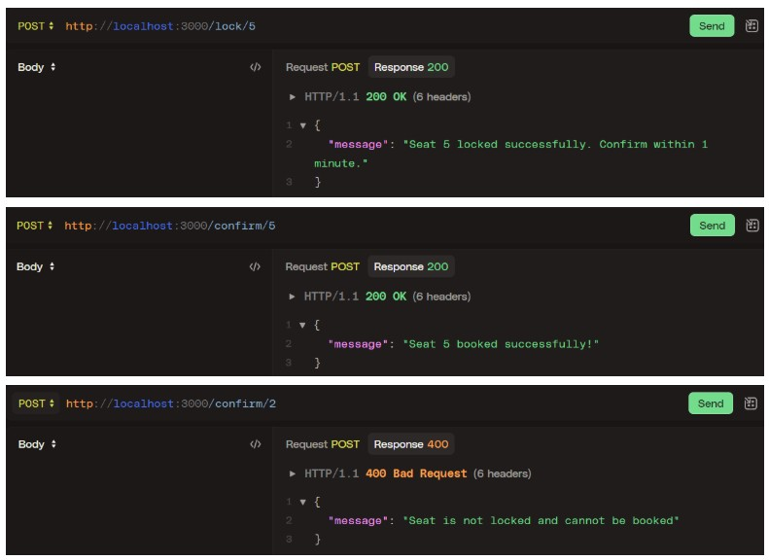

Solution using Node.js and Express.js
Here we require a built-in module of ES6 called Map() to manage the key:value pairs. It also allows to create custom properties on demand.
Here we also require built-in operator of JavaScript called delete to delete the custom properties
Here also required a module uuid to generate Unique Key Code for the values
Here we are creating a custom property called state having states of the seat booking like available, booked, locked etc.
Time is taken in millisecond for 1 minute (60*1000) millisecond

//experiment4.3.js import express from 'express';
import { v4 as uuidv4 } from 'uuid';

const app = express();
app.use(express.json());

const seats = new Map();

for (let i = 1; i <= 10; i++) {
seats.set(String(i), { state: 'available' });
}

const LOCK_DURATION_MS = 60 * 1000;

function clearLock(seat) { if (seat.lockTimeoutId) { clearTimeout(seat.lockTimeoutId); seat.lockTimeoutId = undefined;
}
delete seat.lockId; delete seat.lockedAt; seat.state = 'available';
}

app.get('/seats', (req, res) => { const result = {};
for (const [id, seat] of seats.entries()) { result[id] = { state: seat.state,
}; }
res.json(result);
});

app.post('/lock/:id', (req, res) => { const id = String(req.params.id);
const seat = seats.get(id);

if (!seat) {
return res.status(404).json({ message: `Seat ${id} does not exist.` }); }

if (seat.state === 'booked') {
return res.status(400).json({ message: `Seat ${id} is already booked.` });
}

if (seat.state === 'locked') {
return res.status(400).json({ message: `Seat ${id} is already locked.` }); }

seat.state = 'locked'; seat.lockId = uuidv4();
seat.lockedAt = Date.now();

seat.lockTimeoutId = setTimeout(() => {
// Only clear if still locked (it may have been booked)
if (seat.state === 'locked') { clearLock(seat);
console.log(`Auto-unlocked seat ${id} after timeout.`);
}
}, LOCK_DURATION_MS);

return res.status(200).json({
message: `Seat ${id} locked successfully. Confirm within 1 minute.`
});
});

app.post('/confirm/:id', (req, res) => { const id = String(req.params.id);
const seat = seats.get(id);

if (!seat) {
return res.status(404).json({ message: `Seat ${id} does not exist.` }); }

if (seat.state !== 'locked') {
return res.status(400).json({ message: 'Seat is not locked and cannot be booked' });
}

if (seat.lockTimeoutId) { clearTimeout(seat.lockTimeoutId);
seat.lockTimeoutId = undefined;
}
seat.state = 'booked'; delete seat.lockId;
delete seat.lockedAt;

return res.status(200).json({ message: `Seat ${id} booked successfully!` }); });

const PORT = 3000; app.listen(PORT, () => {
console.log(`Seat-locking server listening on http://localhost:${PORT}`); });

Test it using Postman

